

CODE PIPELINE:
AWS CodePipeline is a continuous delivery service that enables you to model, visualize, and automate the steps required to release your software. ... AWS CodePipeline then builds, tests, and deploys your application according to the defined workflow every time there is a code change

CODE DEPLOY:
AWS CodeDeploy is a service that automates code deployments to Elastic Compute Cloud (EC2) and on-premises servers. Accelerating how fast a developer can release code allows him to release new features for an application faster and avoid deployment errors in complex applications.

OBJECTIVE TO THE CODE DEPLOY AND CODE PIPELINE:

Complete CI/CD with AWS CodeCommit, AWS CodeBuild, AWS CodeDeploy, and AWS CodePipeline



CODE DEPLOY AND CODE PIPELINE PROJECT:
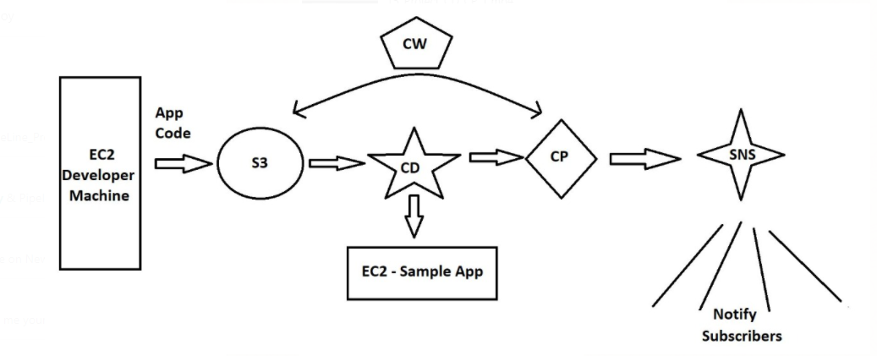

CODE DEPLOY AND CODE PIPELINE PROJECT STEPS:
CodeDeploy is a deployment service from AWS which can automate application deployments to Amazon EC2 instances, on-premises instances or Lambda functions. This does a onetime deployment, for scheduling of deployment you may have to use AWS CodePipeline also.

Application: A CodeDeploy application can be defined from AWS CodeDeploy web console.

Revision: Represents the code need to be deployed on EC2 instance.

Appspec file: This contains the instruction to CodeDeploy, like copying of files, executing the scripts etc during the code deployment process. It is present in the root directory of unzipped code with name appspec.yml.

Deployment Group: Represent set of machines of Lambda function where code has to be deployed.

Deployment: The process of deployment.

Setup in Brief:
I have used two EC2 instance of AMZ2 Linux. First one is the web server we will be configuring, also called CodeDeploy agent. Second EC2 machine is supposed to use by developer where the codes are programmed. The names of the resources in the experiment are arbitrary and may name the resources your own.
- Create IAM Roles for EC2-S3-CodeDeploy access.
- Create IAM user account for developer
- Install and prepare the CodeDeploy agent on webserver.
- Create the code from Developer machine
- Create Codedeploy Application and Push the code to S3 bucket from Developer machine
- Create Deployment Group to include web server
- Create Deployment to push the code to the Webserver
- Test the website configuration

SERVICES REQUIRED: EC2,S3,CD,CP,CW,IAM,SNS
Step 1: Create IAM Roles for EC2-S3-CodeDeploy access:
a) s3 to ec2 full access: s3-ec2-full
select IAM service
goto Roles: select EC2 and click next Permissions
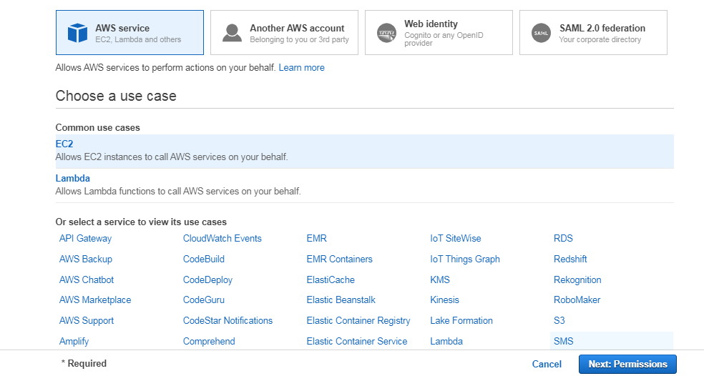

Then select S3fullaccess policy and click Next: Tags
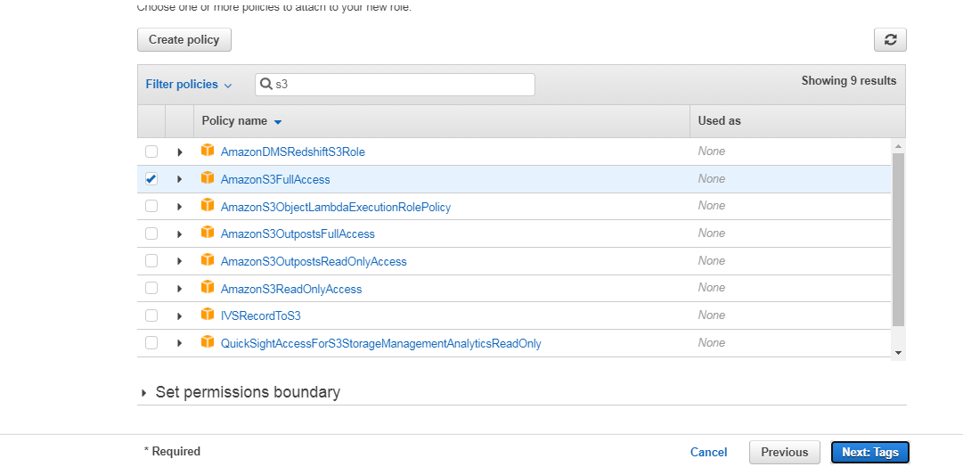

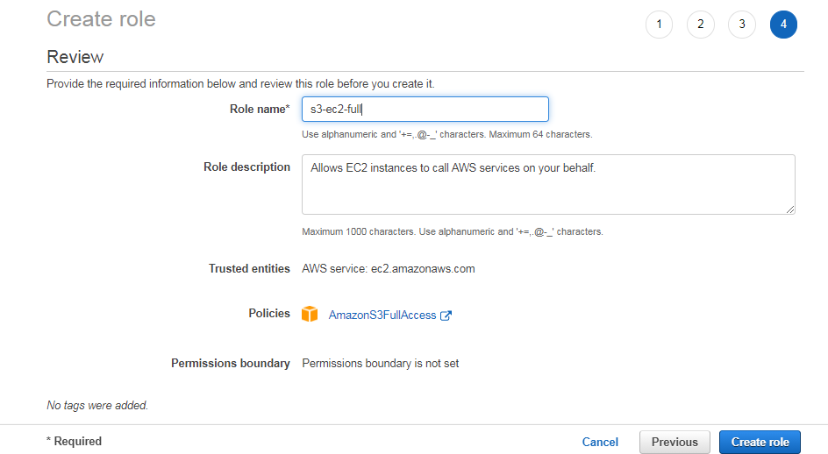

b) Create an Code-Deploy role
Select service CodeDeploy and use case CodeDeploy
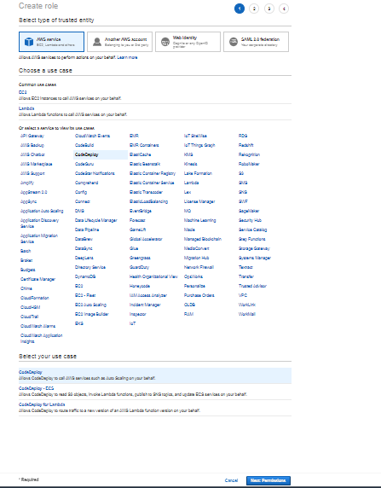

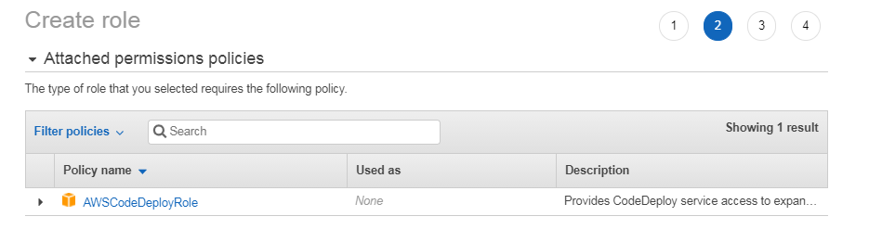

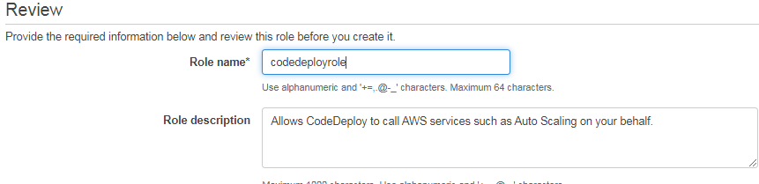

Step 2: Create IAM user account for developer
- Goto users and click add users
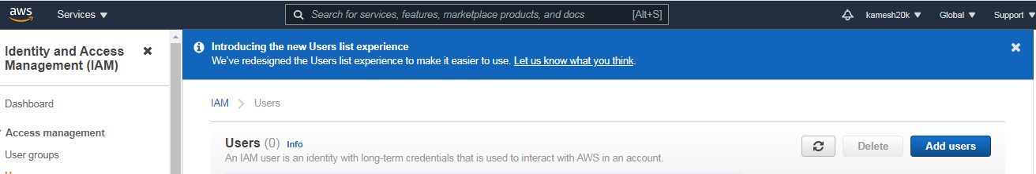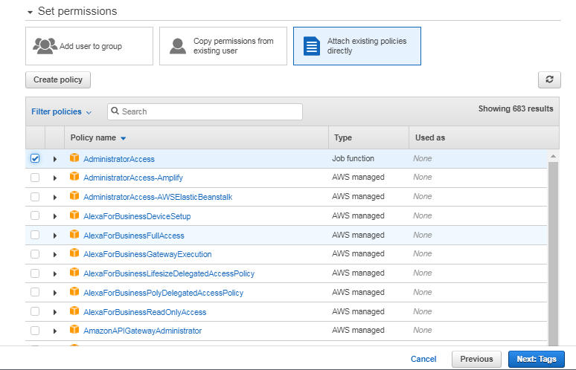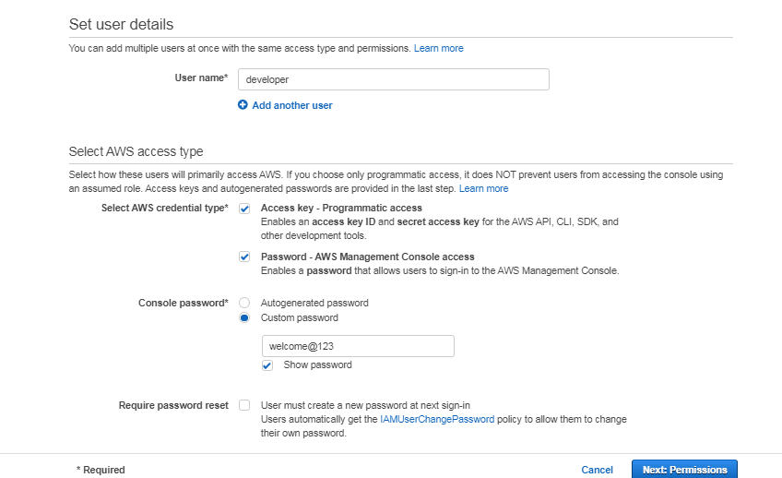

Download .csv file
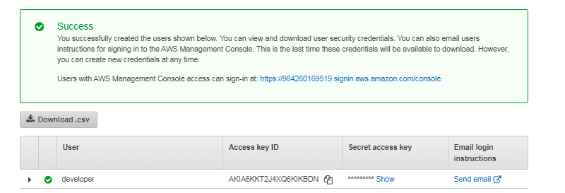

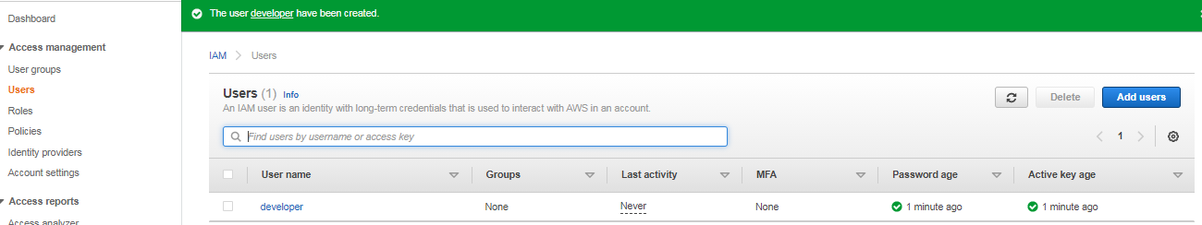

Create Amazon Linux EC2 Server with t2.micro instance type … open all tcp.
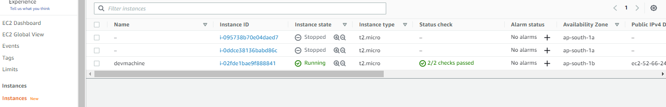

Make this devmachine as a developer machine by configuring user called “developer”.
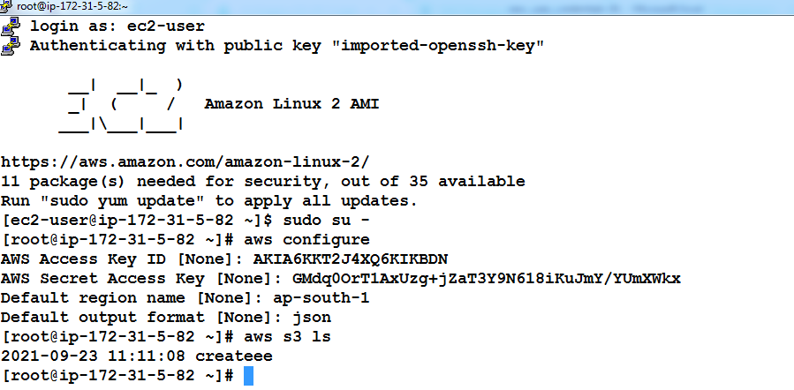

Step 3: Install and prepare the CodeDeploy agent on webserver.-black screen
Create an Amazon Linux Ec2 server and associate s3-ec2-full role

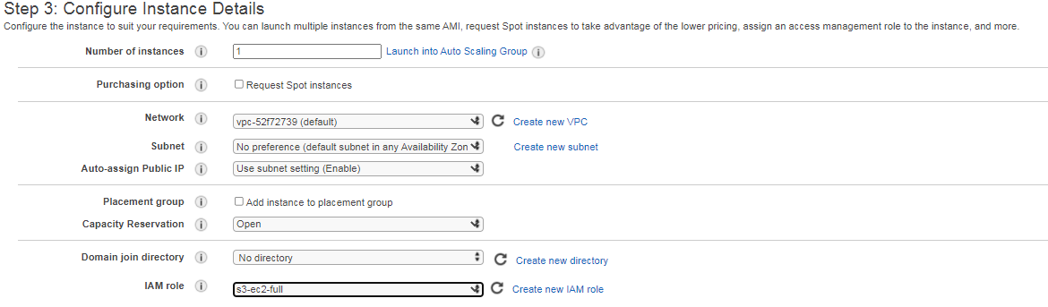

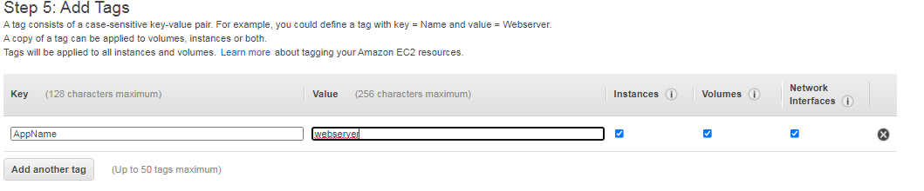

Name doesnot appear becase we named tag as a “AppName”
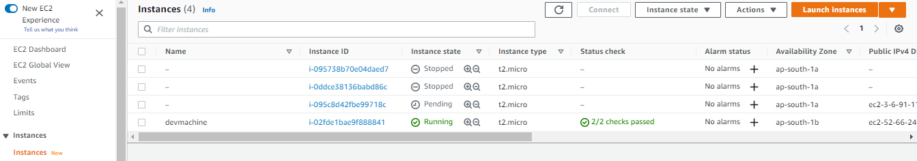

e)
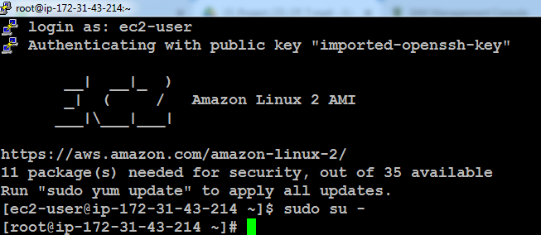

Refresh Environment: yum update
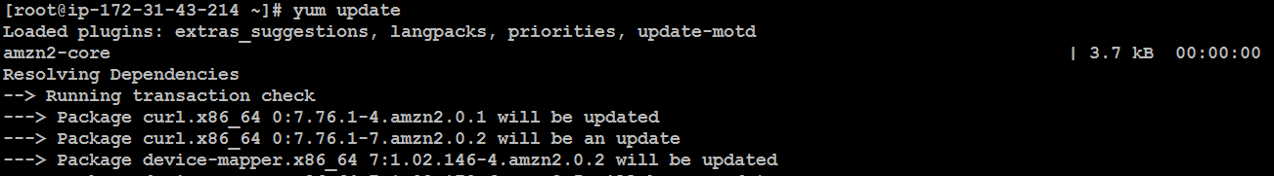

yum install ruby -y
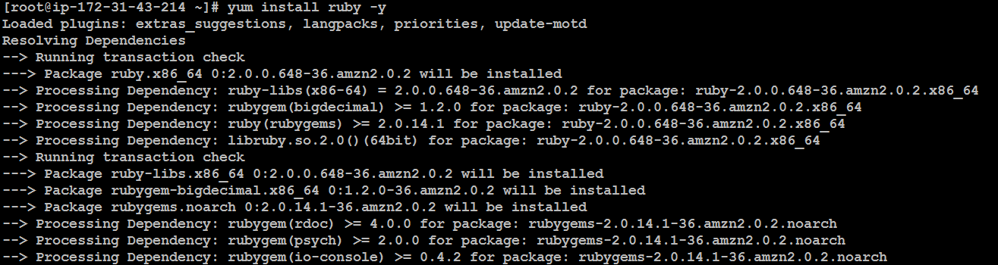

yum install wget -y
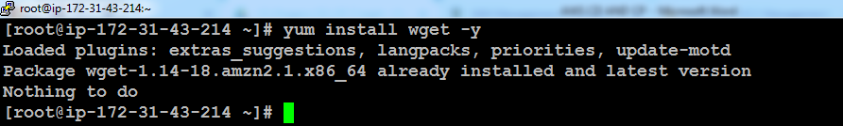

# wget https://aws-codedeploy-us-east-1.s3.amazonaws.com/latest/install
# chmod +x install
#./install auto
# service codedeploy-agent status

wget https://aws-codedeploy-us-east-1.s3.amazonaws.com/latest/install
download install script to install the code deploy agent
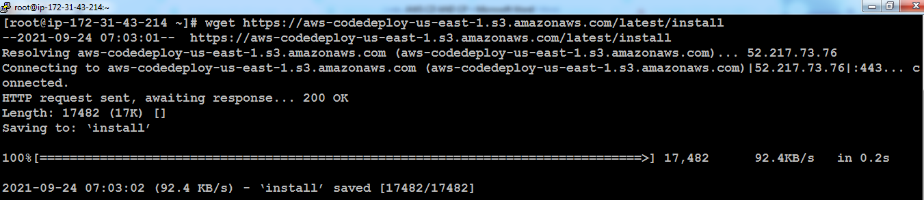

Chmod +x install
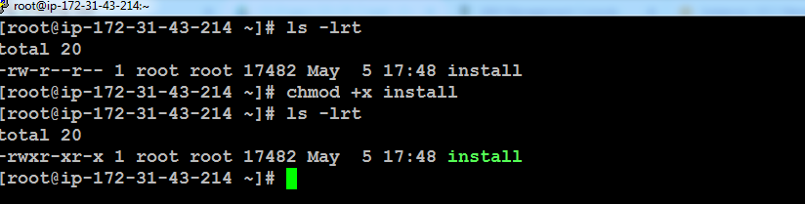

Install the script: By Default it checks on the ruby version.
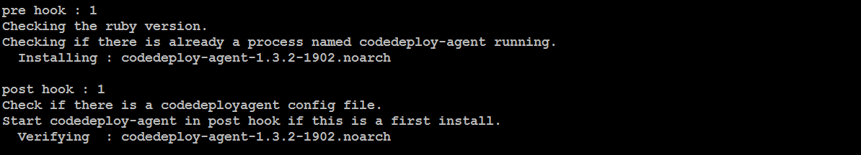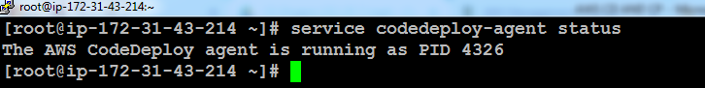

Step 4: Create the code from Developer machine – white machine
Work in root
a)mkdir deploy_dir
cd deploy_dir
mkdir sampleapp
cd sampleapp
ls –lrt
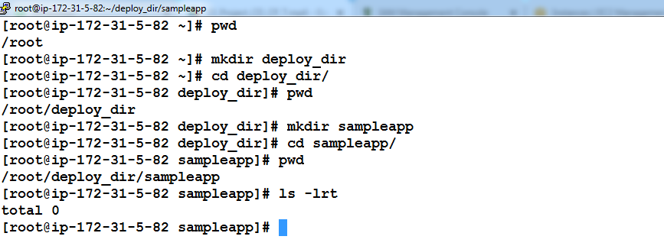

- vi index.html

Enter below content and save using wq!
<html>
<h2> Sample App Version 1 </h2>
</html>

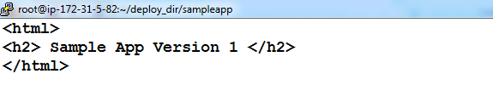
:wq! Then enter

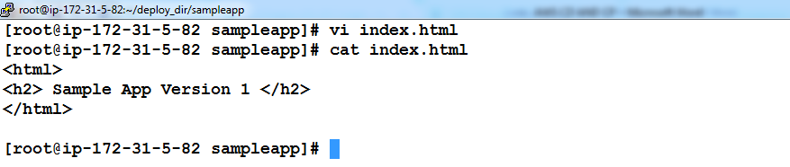

- Create appspec.yml file – This helps to deploy the source code into webserver automatically

version: 0.0
os: linux
files:
- source: /index.html
destination: /var/www/html/
hooks:
BeforeInstall:
- location: scripts/httpd_install.sh
timeout: 300
runas: root
- location: scripts/httpd_start.sh
timeout: 300
runas: root
ApplicationStop:
- location: scripts/httpd_stop.sh
timeout: 300
runas: root

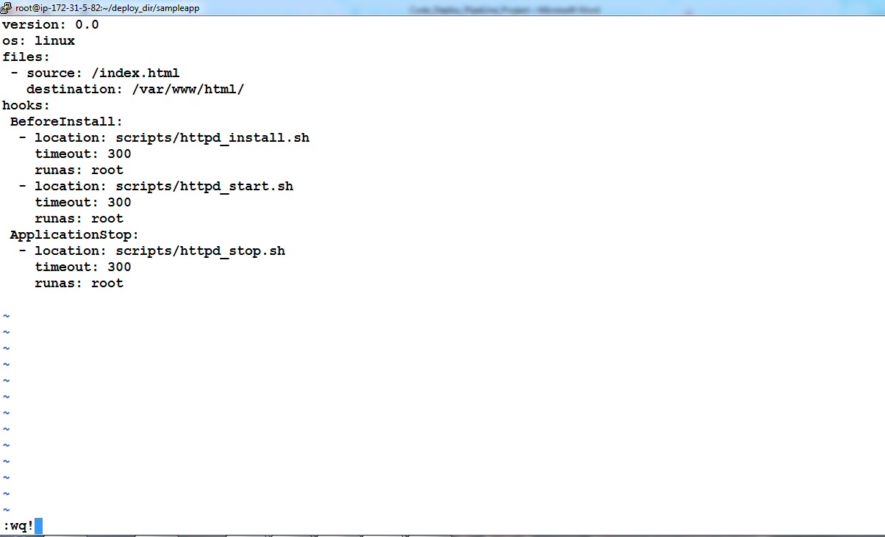

Check: two files has been ready
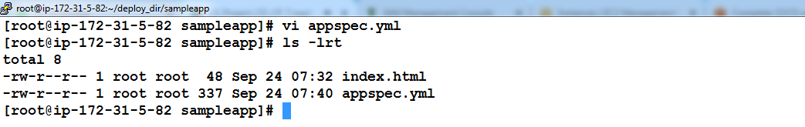
mkdir scripts
cd scripts
vi httpd_install.sh
vi httpd_start.sh
vi httpd_stop.sh

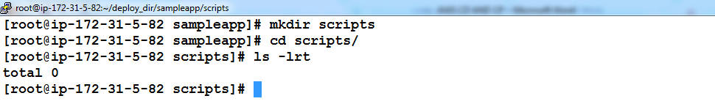

[root@ip-172-30-0-178 deploy_dir]# cat sampleapp/scripts/httpd_install.sh
#!/bin/bash
yum install -y httpd

[root@ip-172-30-0-178 deploy_dir]# cat sampleapp/scripts/httpd_start.sh
#!/bin/bash
systemctl start httpd
systemctl enable httpd

[root@ip-172-30-0-178 deploy_dir]# cat sampleapp/scripts/httpd_stop.sh
#!/bin/bash
systemctl stop httpd
systemctl disable httpd

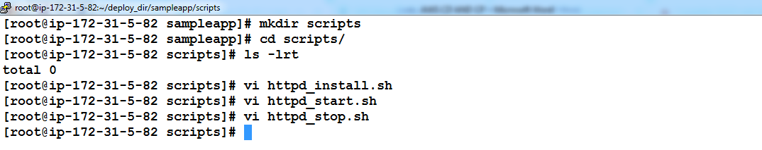

Step 5: Create Codedeploy Application and Push the code to S3 bucket from Developer machine
- Create bucket name called aws24092021 – make it public policy
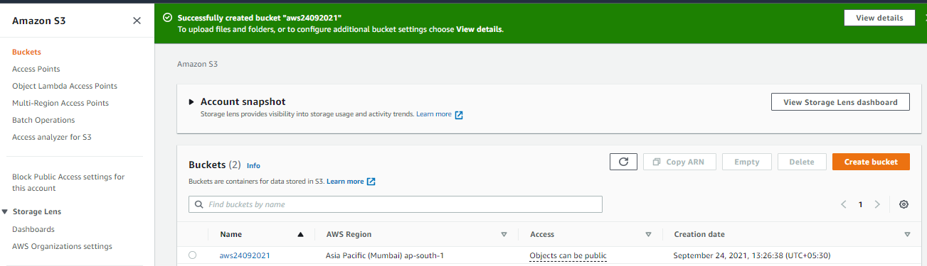

Check the codedeploy in the Console level in GUI
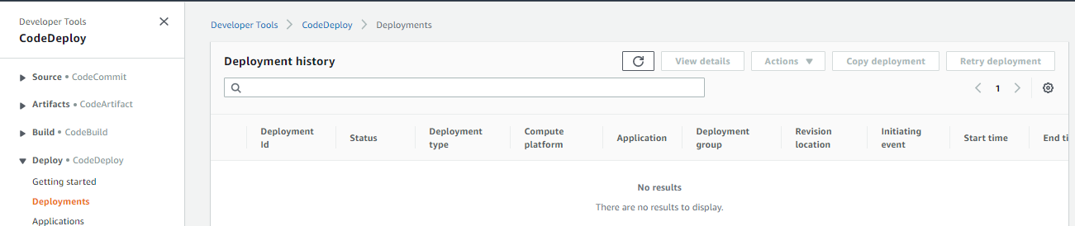

- Create bucket name called aws24092021 – make it public policy
Run the cli and create an application in the code deploy
Note: We might run the command where the appspec.yml kept
# aws deploy create-application --application-name sampleapp

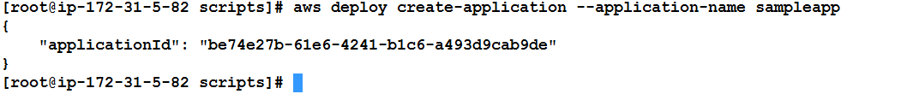

Check and confirm whether the sample application been created successful created in the aws console:

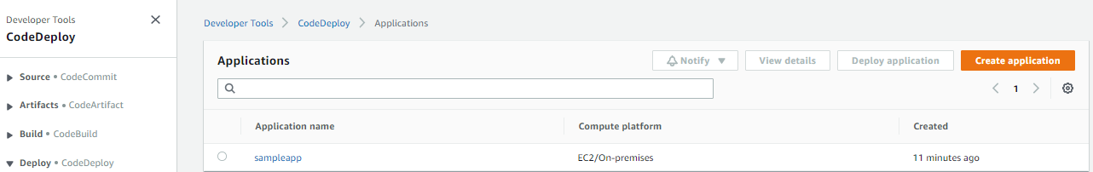

c- Now upload the code to S3 by executing the command below. Directory of execution is important.
aws24092021
# aws deploy push --application-name sampleapp --s3-location s3://aws24092021/sampleapp.zip
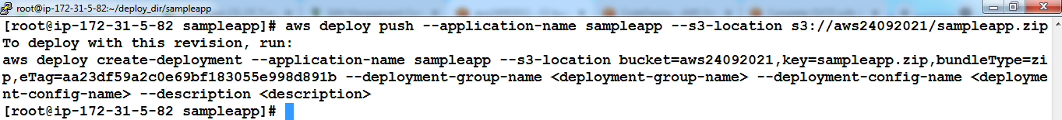

d- Now browse the s3 bucket to see that sampleapp.zip is present.
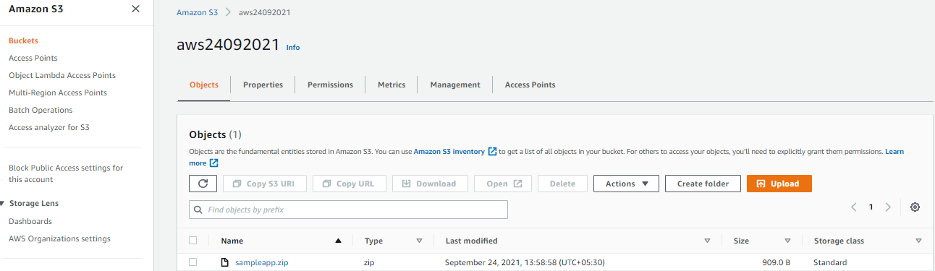

Step 6: Create Deployment Group to include web server
- Login to Codedeply AWS web console
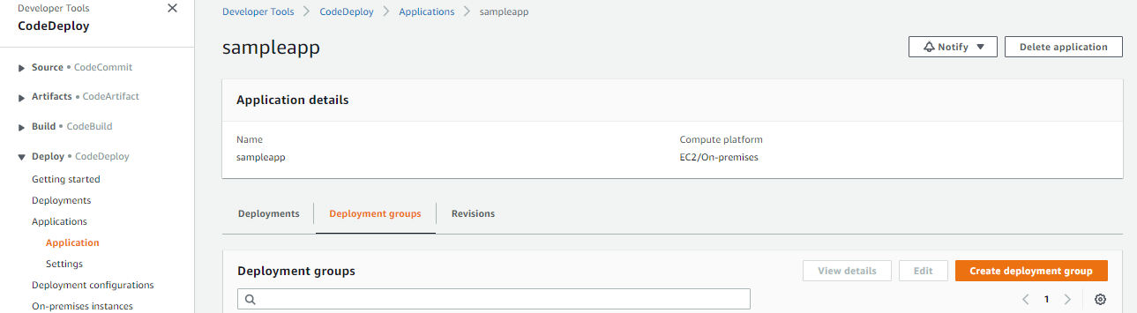

- Select sampleapp and click Create Deployment Group from Deployment Groups tab.
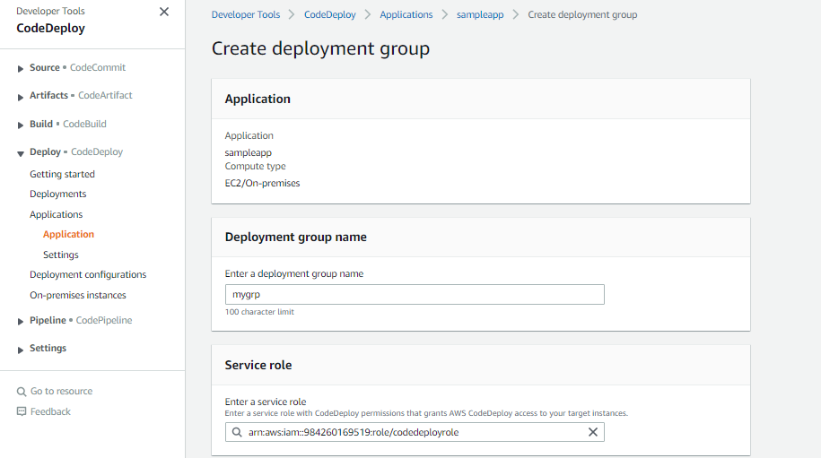
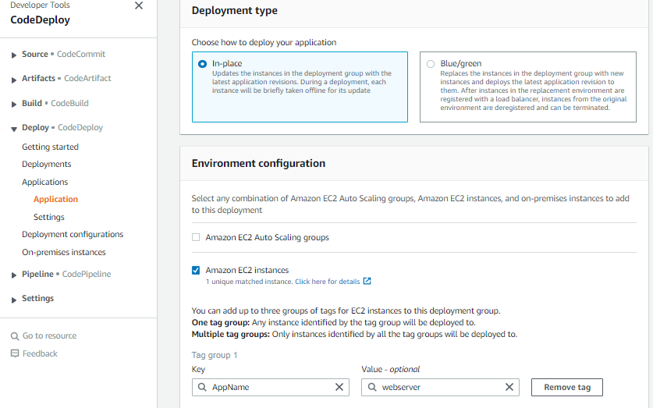

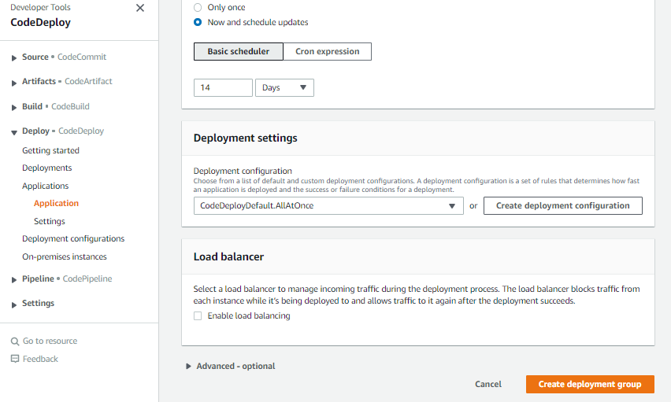

c- Enter the values like below and leave the other parameters default

Enter a deployment group name: mygrp
Choose a service role: cdrole
Deployment type: in-place
Environment configuration: choose Amazon EC2 instances
Key as AppName Value as SampleApp
Load balancer: uncheck Enable load balancing
Click Create Deployment Group button to finish creation of deployment group

7-Create Deployment which pushes code to the webserver
In the sampleapp click Create Deployment. Enter values like below. Other parameter can can be kept default
Deployment group : mygrp
Revision type: My application is stored in Amazon S3
Revision location : s3://select_location_from_list

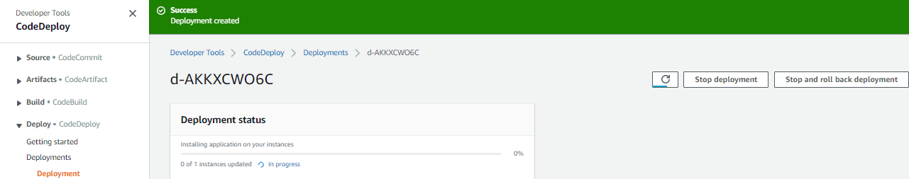

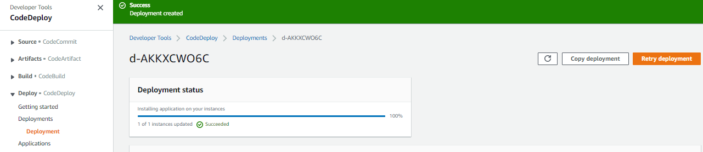

Click Create Deployment to finish

Successfully done the deployment

CREATE PIPELINE TO ENABLE AUTOMATIC DEPLOYMENT MOMENT THE NEW VERSION REACHES THE REPOSITORY CALLED S3

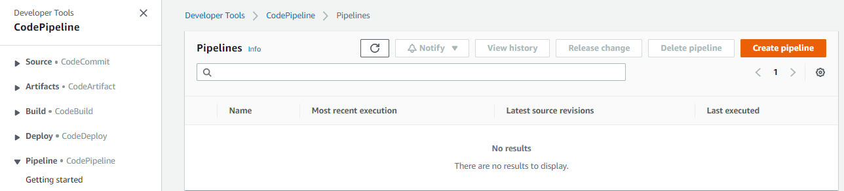

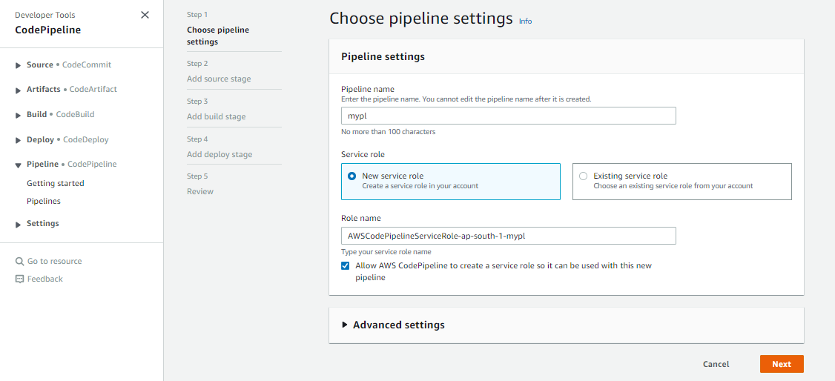
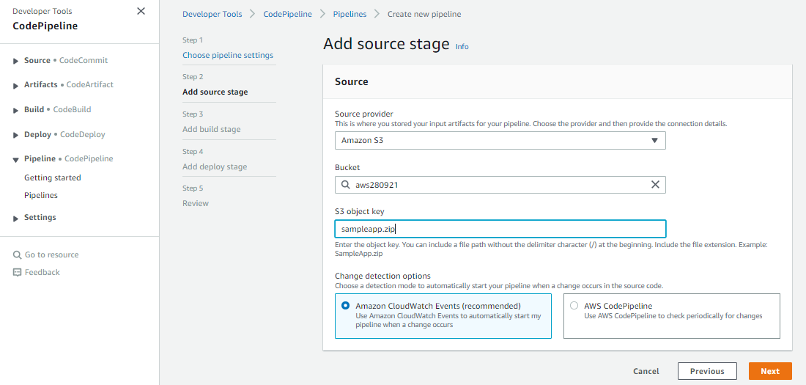

SKIP THE BUILD STAGE AND MOVE ON..
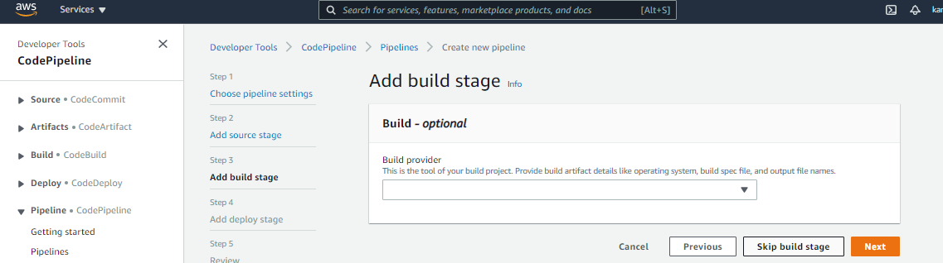

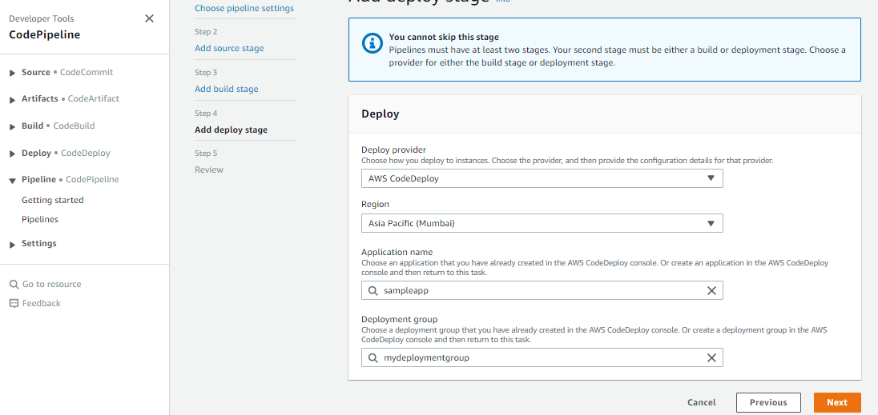

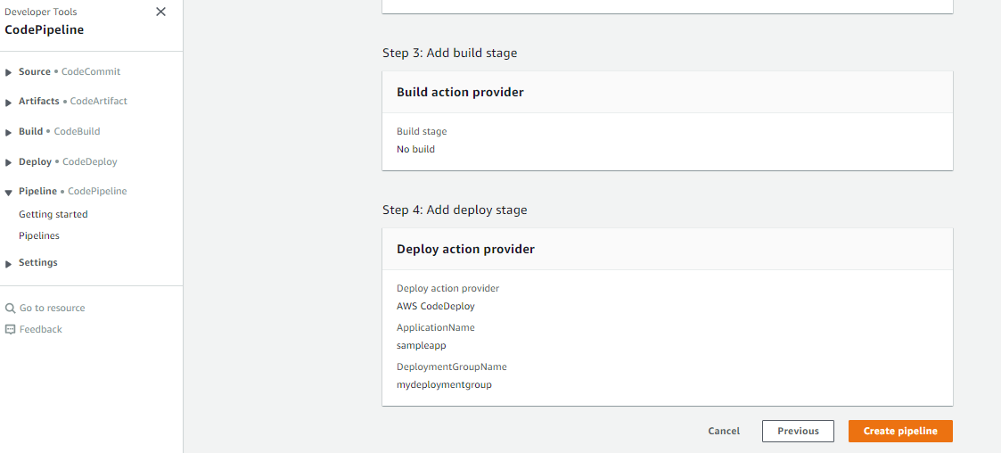

EXCEPTION OCCURES LIKE BELOW,
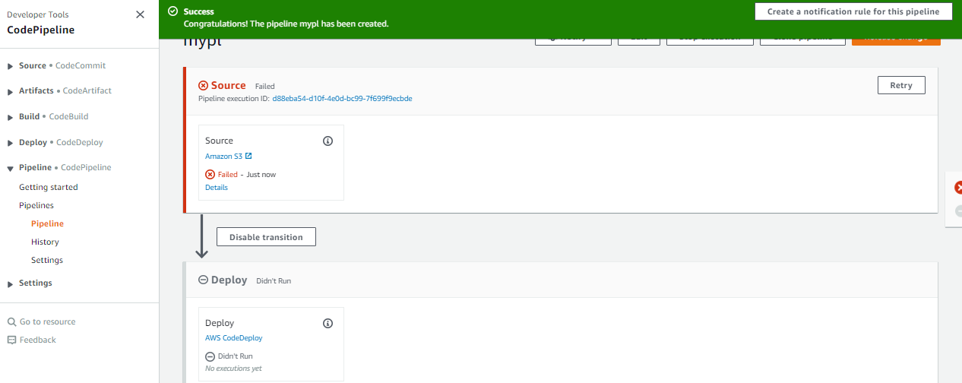

REASON FOR THE FAILURE:
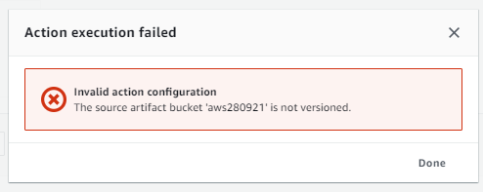

RESOLUTION:
ENABLE BUCKET VERSIONING AND SAVE
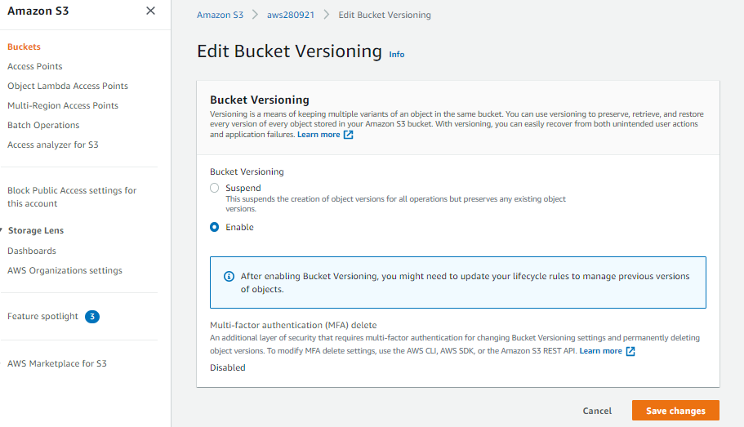

CLICK RETRY….
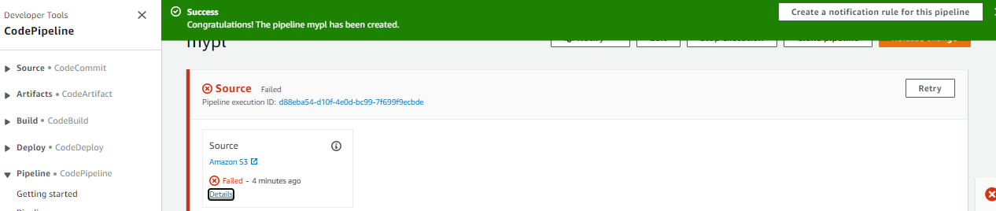

BOTH SOURCE AND DEPLOYMENT GOT SUCCEEDED
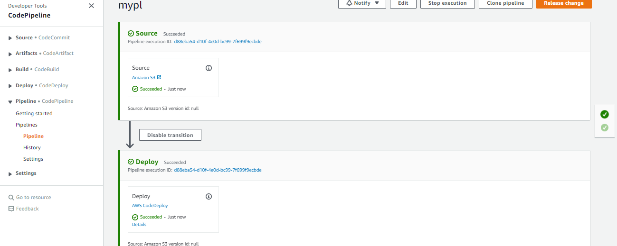

TESTING THE PIPELINE PROCESS:
GOTO DEVELOPER MACHINE AND PUSH NEW VERSION OF THE sampleapp.zip
Edit the content:

[root@ip-172-31-13-20 sampleapp]# vi index.html
<html>
<h2> Sample App Version 2 </h2>
</html>

EXECUTE THE BELOW COMMAND AND CREATE ZIP FILE FIRST
zip -r ../sampleapp.zip .
[root@ip-172-31-13-20 sampleapp]# zip -r ../sampleapp.zip .
adding: appspec.yml (deflated 53%)
adding: scripts/ (stored 0%)
adding: scripts/httpd_install.sh (stored 0%)
adding: scripts/httpd_start.sh (deflated 21%)
adding: scripts/httpd_stop.sh (deflated 21%)
adding: index.html (deflated 9%)

CLICK RETRY….
[root@ip-172-31-13-20 sampleapp]# cd ..

[root@ip-172-31-13-20 deploy_dir]# ls -lrt
total 4
drwxr-xr-x 3 root root 58 Sep 28 07:00 sampleapp
-rw-r--r-- 1 root root 1306 Sep 28 07:01 sampleapp.zip

[root@ip-172-31-13-20 deploy_dir]# aws s3 cp sampleapp.zip s3://aws280921
upload: ./sampleapp.zip to s3://aws280921/sampleapp.zip
[root@ip-172-31-13-20 deploy_dir]#

NEW TIMESTAMP HAS BEEN UPDATED
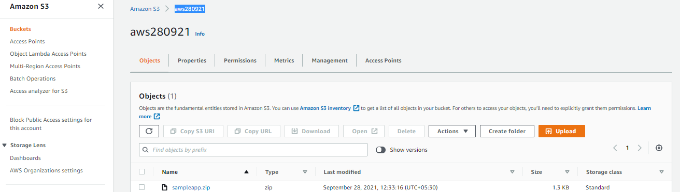

NEW SOURCE CODE HAS BEEN SUCCESSFULLY TRIGGERED FROM S3 BY CODE PIPELINE AND DEPLOYMENT NEW VERSION INTO WEBSERVER
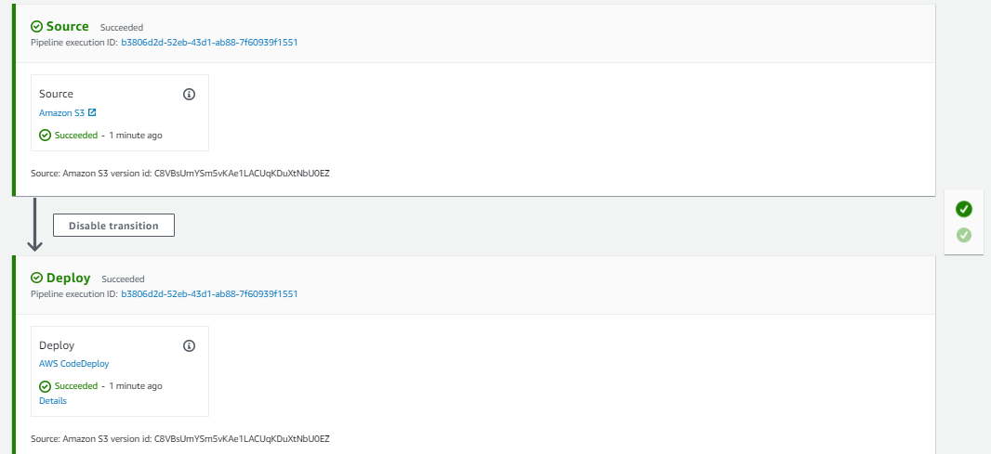

VERIFY THE SAME BY HITTING THE PUBLIC IP OF THE WEBSER MACHINE IN THE BROWSER AND CHECK

ENABLE THE NOTIFICATION SERVICE: ALERTING TO THE USER IN CASE IF THE DEPLOYMENT SUCCEED, FAILED, START ETC

Create SNS name called mytopic and make it as a public
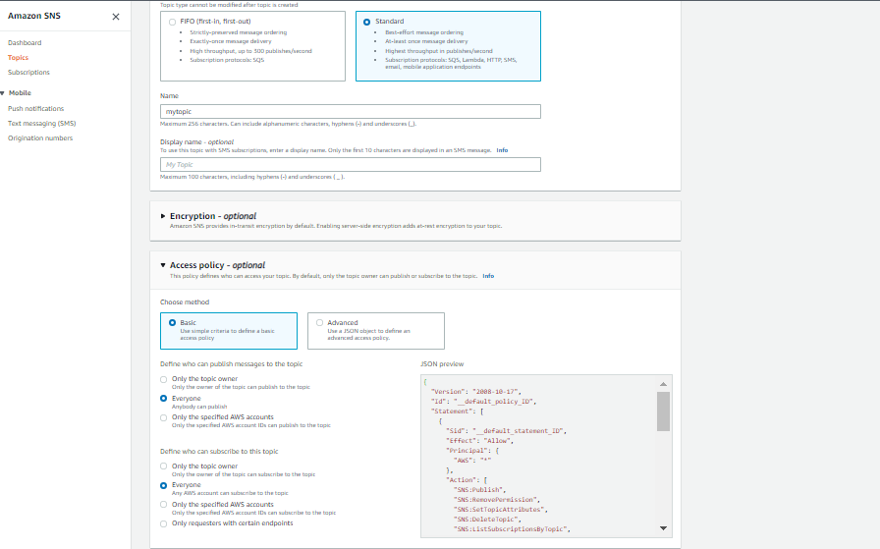

CREATE SUBSCRIPTION1 –USING EMAIL PROTOCOL
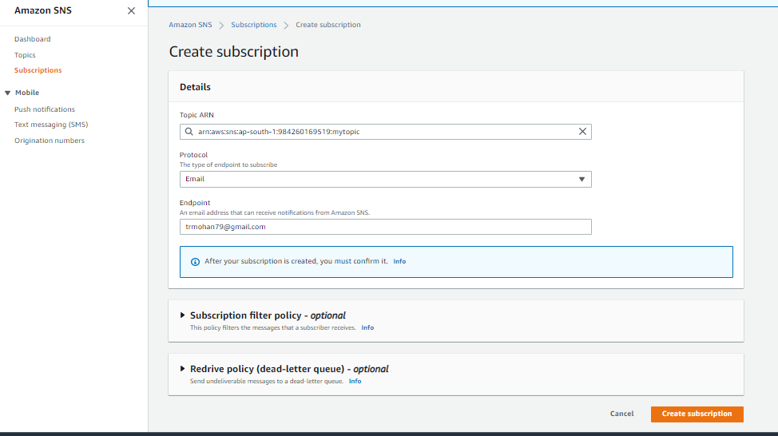

Confirm the subscription since gmail is an third party server for the aws
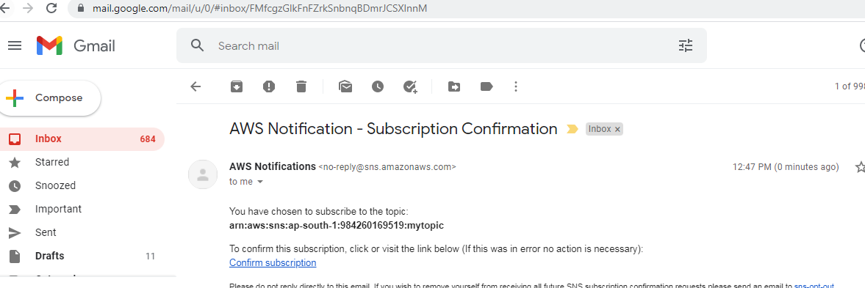

SUBSCRIPTION CONFIRMED
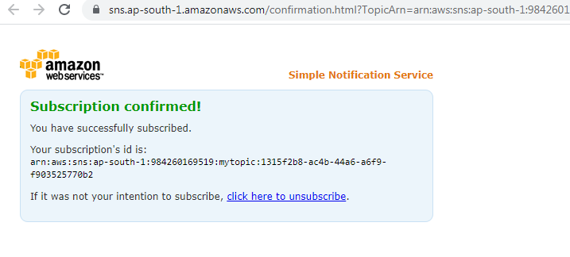

ADD ANOTHER PROTOCOL CALLED SMS
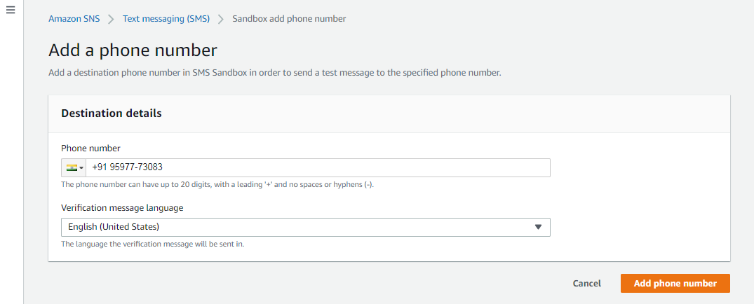

VERIFY PHONE NUMBER
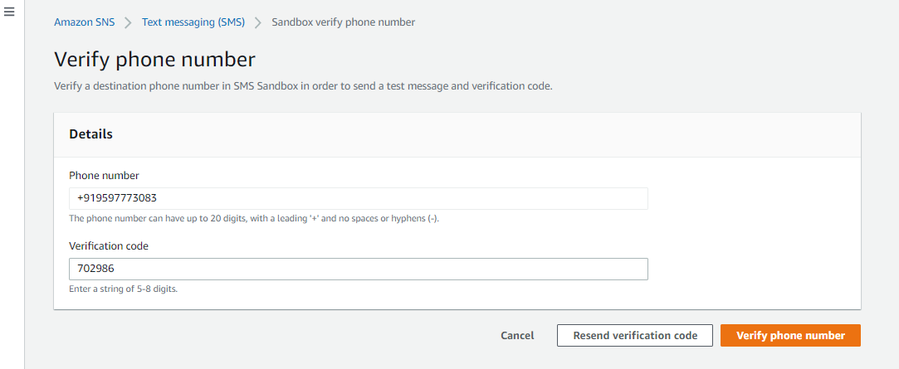

CREATE SUBSCRIPTION
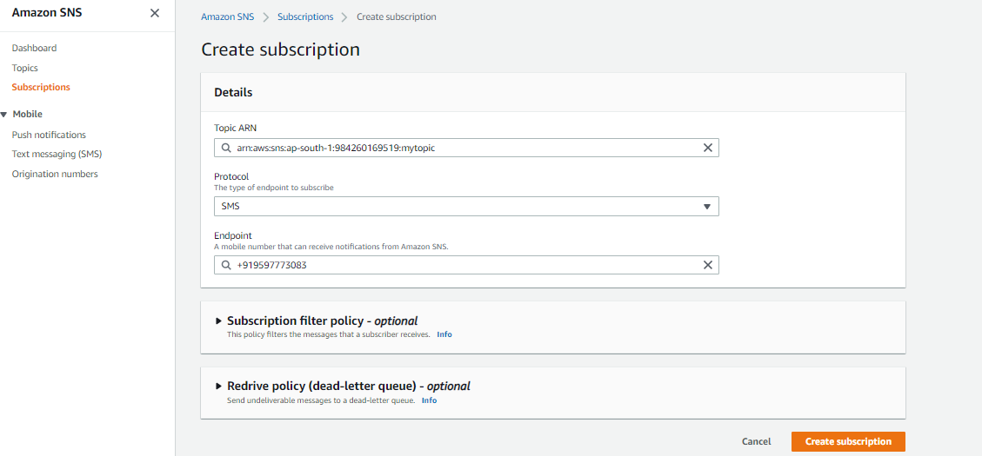

TWO SUBCRIPTIONS HAS BEEN CREATED:

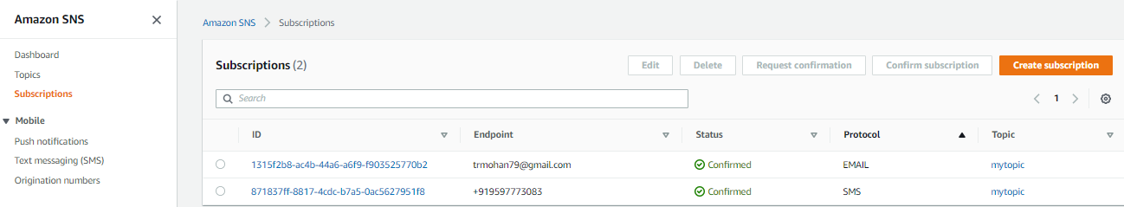

TEST THE DEPLOYMENT ONCE AGAIN WITH SAME STEPS HOW WE FOLLOWED EARLIER AND
- CHANGE THE CONTENT IN THE index.html
- CREATE AN sampleapp.zip
- PUSH THE SOURCE CODE THE S3 BUCKET
- CHECK THE PIPELINE STATUS
- ALSO CHECK THE ALERTING
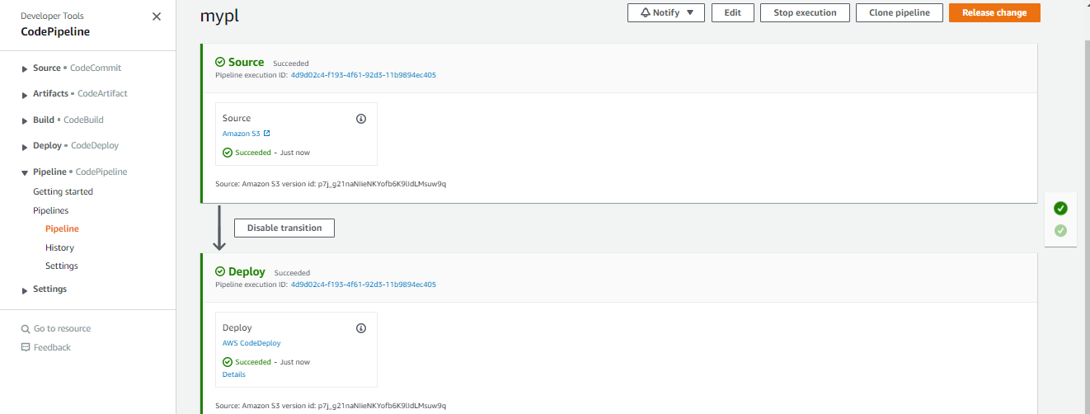

VERIFY THE NEW SOURCE CODE DEPLOYMENT WITH CODE PIPELINE
SUCCESSFULLY DONE

EMAIL NOTIFICATION:
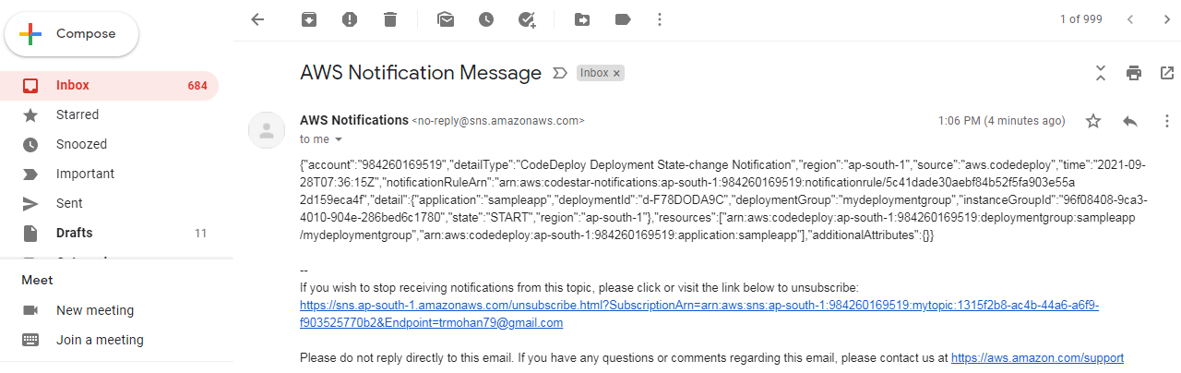

SMS NOTIFICATION:

{"account":"984260169519","detailType":"CodeDeploy Deployment State-change Notification","region":"ap-south-1","source":"aws.codedeploy","time":"2021-09-28T07:36:25Z","notificationRuleArn":"arn:aws:codestar-notifications:ap-south-1:984260169519:notificationrule/5c41dade30aebf84b52f5fa903e55a2d159eca4f","detail":{"application":"sampleapp","deploymentId":"d-F78DODA9C","deploymentGroup":"mydeploymentgroup","instanceGroupId":"96f08408-9ca3-4010-904e-286bed6c1780","state":"SUCCESS","region":"ap-south-1"},"resources":["arn:aws:codedeploy:ap-south-1:984260169519:deploymentgroup:sampleapp/mydeploymentgroup","arn:aws:codedeploy:ap-south-1:984260169519:application:sampleapp"],"additionalAttributes":{}}

DEMOLISH:
  - DELETE INSTANCES
  - DELETE CODE DEPLOY
  - DELETE CODE PIPELINE
  - DELETE BUCKET AND OBJECT
  - DELETE SNS TOPIC AND SUBSCRIPTIONS
  - DELETE IAM ROLES AND USERS

